School: | St Mary’s Catholic Primary School, Marnhull
SENCO: | Sharon Betts
Date of report: | July 2022
SEN Governor: | Nick Chambers

SEND profile for last 12 months

- 24 (30%) pupils on SEN register, including 4 pupils with Education Health and Care Plans
- 7 pupils are also in receipt of pupil premium
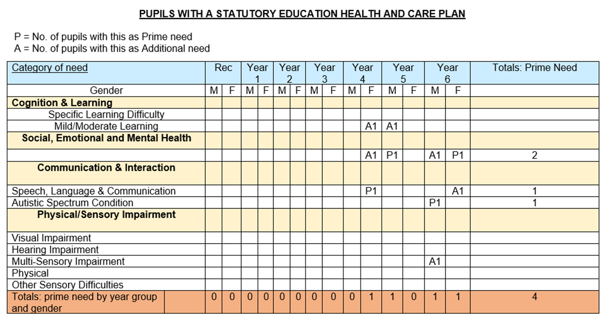
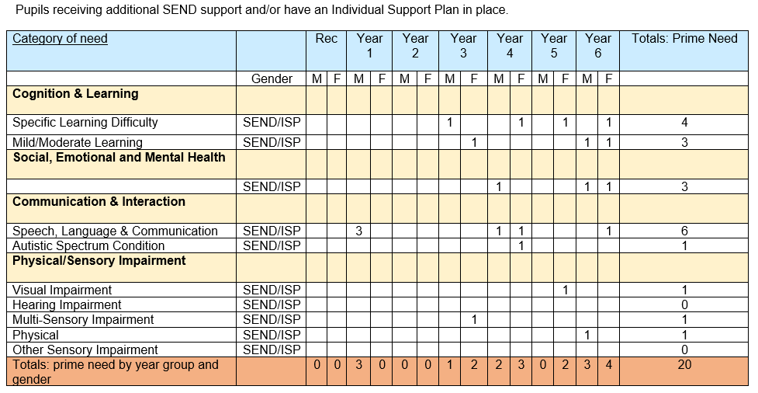
- 4 pupils were put on the register

Overall quality of provision for pupils with SEND
Quality of education for pupils with SEND
- All pupils study a full and broad curriculum, including in Year 6 and those pupils with SEND.
- During the learning journey, a range of objectives in several curriculum subjects are addressed and adapted to meet the needs of pupils with SEND. They are considered and included in all aspects of learning and school life, whilst also being supported to increase their independence
- Teachers are strong at supporting most pupils with SEND, however supporting those with more challenging behaviours to engage with learning needs further development.
- Throughout lessons pupils with SEND are fully integrated and learning is scaffolded in ways to support their engagement. RWI, Fresh Start, Power Maths, Jane Considine approach to writing – all follow Rosenshine’s principles, through effective modelling, small chunks, I do, we do, you do. Etc
- There are high expectations for all learners and pupils with SEND have equality of access to qualified teachers. Quality First Teaching is our first intervention. TAs support learners across the ability groups so that all ability groups are taught by the class teacher.
- There are opportunities built in every week for teachers to work either 1-1 or in small groups with specific children, many of these are on SEND register – depending on needs at a given time.
- Transition is in place for moving to secondary school, with enhanced support in place for those pupils who need it. Transition for pupils within school moving from one teacher to the next is also in place – teachers meet to share knowledge and expertise of the pupils, opportunities for the teacher to meet with the pupils and if necessary this is enhanced.
Outcomes for pupils with SEND
- Data shows pupils with SEND are making progress.
Summer 2022 |  | Reading |  | Writing |  | Maths
 |  | Att | Prog | Att | Prog | Att | Prog
Att | EXS+ | 8/24 33% |  | 8/15 53% |  | 10/15 67%
 | GDS | 4/24 17% |  | 0/15 0% |  | 2/15 13%
Prog | Exp prog+ |  | 21/24 88% |  | 21/24 88% |  | 21/24 88%
 | Better Exp prog+ |  | 4/24 17% |  | 2/24 8% |  | 8/24  33%
- 88% of pupils with SEND make at least expected progress from their starting points in Reading, Writing and Maths – due to our inclusive ethos, we have had several vulnerable children join us who are significantly behind with their learning. This is a challenge for the school.
Effectiveness of leadership and management for SEND
- HT/SENDCo is an experienced SENDCo of 19 years in a previous school (1998-2017). She is currently undertaking the NASENDCo accreditation award through Exeter University.
- HT/SENDCo visits classes regularly and observes pupils’ response to learning. HT/SENDCo teaches in every class, every week.
- Book scrutinies are undertaken regularly and show differentiation through scaffolding, support and outcome.
- Professional dialogues occur around children’s learning.
- Pupil progress meetings take place termly.
- HT/SENDCo has termly planning meeting with Educational Psychologist and Specialist Teacher from Dorset.
- HT/SENDCo reviews registers at least termly following Pupil Progress meetings or upon meetings with parents or external agencies.
- HT/SENDCO has been successful in securing 2 EHCPs.
Personal development, behaviour and welfare of pupils with SEND
- Pupils with SEND are meaningfully involved in all aspects of school life alongside their peers. All children are given the opportunity to put themselves forward for leadership roles:
  - 2 pupils are on School Council
  - 3 pupils are Librarians
  - 4 pupils are on GIFT team
- There have been 4 fixed term exclusions for half a day this year. We have made reasonable adjustments in order to take into account the changes faced by this pupil and are working with external agencies to further support.
SEN policy
SEND policy is a Trust-wide policy and was reviewed in September 2021.
SEN information report on school website
SEND Information report was reviewed in October 2021 and meets statutory requirements.
Statutory assessments
Access arrangements were made for 3 pupils who were eligible to have extra time and if necessary a 1-1 reader. Use and effectiveness of access arrangements
Staffing for SEND
Quality First Teaching is our first intervention. TAs support learners across the ability groups so that all ability groups are taught by the class teacher. ELSA in place and attends regular supervision.
Interventions
- Not many interventions in place:
  - RWI/Fresh Start for pupils in KS2 (data)
  - Beat Dyslexia
  - Learn to Move, Move to Learn (Termly progression reports)
  - ELSA (discussions with ELSA).
  - Targeted SALT interventions
CPD for SEND
- HT/SENDCO is currently undertaking the NASENDCo accreditation award through Exeter University.
- All staff attended INSET on Selective Mutism to support 2 pupils in school.
- All staff have had access to Trauma Informed Approach through PACE.
- ELSA has regular supervision.
- All staff delivering RWI have had training bespoke to their needs and continue to do so.
- All staff have had training using Specialist Teacher webinars for Positive Behaviour Management
- ELSA and HT/SENDCO have undertaken Dorset STEPS behaviour course
- HT/SENDCO attends termly Trust SENDCO Network meetings
Pupil voice
- Pupils actively contribute to their review meetings wherever possible and their views are reflected on paper with a trusted adult
- Pupils with SEND are represented throughout school groups as all pupils are given the opportunity to put themselves forward for leadership roles
  - 2 pupils are on School Council
  - 3 pupils are Librarians
  - 4 pupils are on GIFT team
Parent/carer voice
- As a small school, we know each and every child and family. “Relationships between staff, pupils and parents are strong. Staff know pupils as individuals. Many parents were once pupils themselves at the school.” Safeguarding review July 2021
- Parents have opportunities to meet with class teacher at least termly
- Support plans shared with parents at least termly
External agencies
- Termly planning meetings with Dorset Educational Psychologist (EP) and Specialist Teacher
- Ongoing liaison with Speech and Language Therapist (SALT)
- Meetings with SALT during Assessment for EHCP
- Meetings with EP during Assessment for EHCP
Are there any concerns regarding provision for pupils with SEND?
Accessing support out of county e.g. Somerset is extremely challenging. Too often bureaucracy hinders supporting children who need it.

