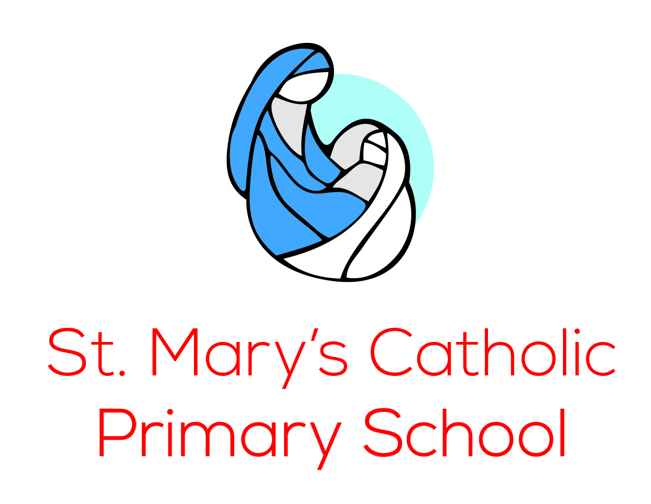

Charging and Remissions Policy

Reviewed by the Full Governing Body November 2022
Next Review November 2025

Charging and Remissions Policy

Introduction
All education during school hours is free. At St Mary’s we do not charge for any activity undertaken as part of the National Curriculum with the exception of some individual or small group music tuition.

Voluntary contributions
When organising school trips or visits to enrich the curriculum and the educational experiences of children, the school invites parents to contribute to the cost. All contributions are voluntary however if we do not receive sufficient voluntary contributions to cover the cost, we may cancel a trip. If a trip goes ahead, it may include children whose parents have not paid any contribution. We do not treat these children differently from any others. The 1988 Education Act draws a distinction between the term ‘charges’ which are considered to be an obligatory cost and ‘voluntary contributions’ which are self-explanatory.

Subsidies from various sources eg. School budget, St Mary’s FC (Families and Community), voluntary organizations, grants etc will be considered to cover deficits. Surplus finance will be used via the school fund for the benefit of the children.

Whenever possible and for residentials and more expensive activities, St Mary’s will give sufficient notice to allow parents/carers to pay by instalments.

For children who are entitled to Free School Meals or who have been eligible over the previous 6 years, the school receives Pupil Premium. Also, the Service Premium is paid to schools in respect of any child with a parent currently serving in the armed forces. Both the Pupil and Service Premiums are used by St Mary’s to cover any deficits in voluntary contributions where the eligible children are taking part as well as providing a range of support within the school for eligible children.

The following is a list of additional activities organised by St Mary’s which require voluntary contributions from parents. These activities are ‘optional extras’ and the list is not exhaustive:

- Visits to museums
- Sporting activities
- Outdoor adventure activities
- Visits to or by a theatre company
- School trips
- Musical events
- Transport required for any of the above events

Residential visits
If the school organises a residential visit in school time or mainly in school time, which is to provide education directly related to the National Curriculum, we do not make any charge for the education. However we do make a charge to cover the cost of board and lodging and transport.

Music Tuition
All children study music as part of the normal school curriculum and we do not charge for this.

There is a charge for individual or small group tuition as this is an additional curriculum activity and not part of the National Curriculum. These individual or small group lessons are taught by peripatetic music teachers who charge for these lessons. We give parents information about additional music tuition on request.

Swimming
The school provides swimming lessons. We inform parents when the lessons are to take place and ask for their written permission for their child to take part. Because we do not have on-site swimming facilities, parents/carers are asked to make a voluntary contribution to help cover the cost of the pool facilities and transport.

After school activities.
St Mary’s offers additional activities after school and at lunch breaks. We reserve the right to make a charge for these sessions to cover the cost of more specialised materials and equipment.

Breakfast and After School Club
St Mary’s offers wrap around care through its Breakfast and After School Clubs. As this is child care provision outside of the school day, parents/carers are expected to pay the relevant graduated cost for the sessions per child in full for those used.

