 St. Mary’s Catholic Primary School, Marnhull

Dear Parent/Carer,

We are delighted to be providing hot school meals for the pupils at St Mary’s Catholic Primary School and welcome your children to explore our exciting menu which has been specifically designed to cater for young children.

Attached to this letter is the Hot Lunch Menu which runs until October 2024 Half Term and *Chartwells Online Ordering Guidelines* booklet. School meal orders can be placed via the Dorset Meal Selector website: [*Dorset Meal Selector | Home*](https://nam11.safelinks.protection.outlook.com/?url=https%3A%2F%2Fdorset.mealselector.co.uk%2F&data=05%7C01%7Cdonna.blake%40compass-group.co.uk%7Caa30fe76dc9b4b7c689208da2d14b3f3%7Ccd62b7dd4b4844bd90e7e143a22c8ead%7C0%7C0%7C637871864184832079%7CUnknown%7CTWFpbGZsb3d8eyJWIjoiMC4wLjAwMDAiLCJQIjoiV2luMzIiLCJBTiI6Ik1haWwiLCJXVCI6Mn0%3D%7C3000%7C%7C%7C&sdata=pMOl%2B9h3rbxu24sc8XDFU7c8mrM0jaXcEDYc6cP5TUk%3D&reserved=0)

The online guide describes the process on how to register and place your hot meal orders for week commencing 2nd September 2024 and beyond **please note that you will need to place your order by midnight on Sunday 18th August 2024**. You will be able to access the online system at the end of July 2024 to allow you to place meal orders for the new term.

Children in Reception, Year 1 and 2 are automatically entitled to receive Universal Infant Free School Meals (UIFSM). On average the saving when switching to school meals is approximately £400 per year. Children in Year 3 and above may also be entitled to receive Free School Meals if parents are in receipt of financial support, please visit your school’s or Local Council’s website for details on how to apply.

We recommend that you book meals for the whole term to ensure meals have been ordered without having to remember to book them on a weekly basis.  Please note that there are 3 options daily and the menu runs on a 3-week cycle, should your child prefer a different meal after trying what is booked for them, you can easily alter this on our website as long as it is in line with our 14-day cut-off.

We also offer Medical Diet meals covering all 14 EU Allergens.

If you have any questions or require any assistance, please email us on:

[**BPDadmin@compass-group.co.uk**](mailto:BPDadmin@compass-group.co.uk)

Thank you

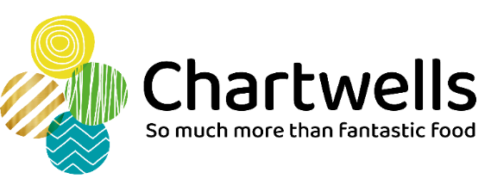

https://www.chartwells.co.uk/