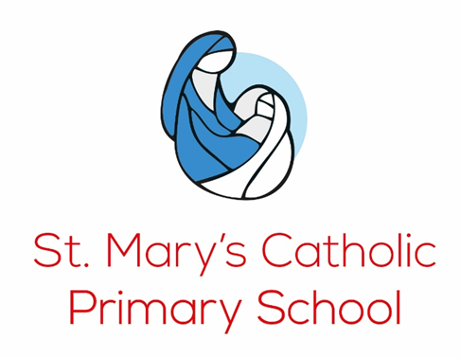

**Religious Education (RE) Policy**

To love, value and respect each other within the Catholic family; to nurture each individual’s talents and skills, as Jesus taught us.

#### 

#### 

#### ***Everyone matters and is loved by God.***

#### **Aims**

At St Mary’s Catholic School, we are committed to the Catholic Faith, recognising and valuing every individual as special and unique and made in the image and likeness of God. We see RE as the core of the curriculum through which we develop each child’s innate capacity for awe, wonder, reverence and spirituality. We aim to promote an invitation to a personal relationship with Christ while fostering knowledge and understanding of the Catholic faith. Teaching Religious Education is the main reason Catholic schools exist. The primary goal of Religious Education is to increase the knowledge and understanding of the Christian message for all pupils in Catholic schools. As such it will be planned, taught, assessed and monitored with the same rigour as other core curriculum subjects.

Our intent is to inspire our children, not to have more but to be more. We equip children with the knowledge and skills to answer challenging questions, explore beliefs, values and traditions in the Catholic and in other faiths. We also teach the children that our role is to help others in need and care for the world we have been given, and so do this through Catholic Social Teaching.

#### **Vision**

Our vision for RE includes:

* To present engagingly a comprehensive content which is the basis of knowledge and understanding of the Catholic faith;
* To enable pupils continually to deepen their religious and theological understanding and be able to communicate this effectively;
* To present an authentic vision of the Church’s moral and social teaching so that pupils can make a critique of the underlying trends in contemporary society;
* To raise pupils’ awareness of the faith and traditions of other religious communities in order to respect and understand them;
* To develop the critical faculties of pupils so that they can relate the Catholic faith to daily life;
* To stimulate pupils’ imagination and provoke a desire for personal meaning as revealed in the truth of the Catholic faith;
* To enable pupils to relate the knowledge gained through Religious Education to their understanding of other subjects in the curriculum;
* To bring clarity to the relationship between faith and life, and between faith and culture

#### **Gospel Values**

#### At St Mary’s Catholic Primary School and in all aspects of the curriculum we promote Gospel Values.

#### Our shared Gospel Values are:

#### **Humility** ‘I am among you as one who serves’ Luke 22:26

#### We respect each other’s feelings, views, cultures and property; We understand that each of us has rights and responsibilities.

#### **Compassion** ‘Whatever you did for one of the least of these brothers of mine, you did for me’ Matthew 25: 39

#### We are motivated to focus on each other’s needs.

#### **Kindness** ‘Love your neighbour as yourself’ Matthew 22:39

#### We are caring and thoughtful towards others; We are ready to help each other.

#### **Justice** ‘Blessed are those who always do what is right’ Psalm 106: 3

#### We are motivated to make the right choice; We understand why appropriate behaviour is required.

#### **Forgiveness** ‘Be merciful, just as your father is merciful ‘Luke 6:36

#### We show mercy and forgiveness towards others; We take ownership of our behaviour, are helped to consider consequences and learn from our mistakes.

#### **Integrity** ‘the Lord delights in people who are trustworthy’ Proverbs 12:22

#### We are honest and truthful and take responsibility for our behaviour; We are polite and demonstrate good manners

#### **Peace** ‘I leave you, my peace I give you’ John 14:27

#### We are always ready to discuss disagreements openly; We treat everyone with dignity and respect and are non-violent

#### **Courage** ‘Take courage! It is I. Do not be afraid’ Mark 6:49

#### We experience success and meet challenges positively; We are responsible and responsive

**Catholic Social Teaching**

At St Mary’s we teach children about the principles of Catholic Social Teaching (CST). As Catholics, we believe that it is our role to help others in need and care for the world we have been given. We use the CAFOD resources to support teaching and learning related to CST.

These principles of Catholic social teaching are included in all areas of the curriculum:

* Human Dignity
* Stewardship
* The Common Good
* Participation
* Subsidiarity
* Distributive Justice
* Preferential Treatment for the Poor
* Promoting Peace

#### **Programme of Study**

#### RE is allocated 10% of total teaching time, emphasising its status as a core subject.

We follow *To Know You More Clearly*, a diocesan-approved scheme based on the Second Vatican Council, the Catholic Catechism, and the revised RE Curriculum Directory. The model curriculum: The curriculum comprises six branches which are organised into year groups. These branches align with the liturgical year, as well as a six term school year. The curriculum is robust, sequenced and progressive. At its centre is the study of scripture. The curriculum requires pupils to have regular opportunities to engage in critical and creative thinking and in personal reflection. It enables pupils to make meaningful connections between scriptural texts (hear), Catholic beliefs (believe), prayer and liturgy (celebrate) and the relationship of faith to life (live).

#### **Monitoring and Evaluating**

The success of our RE curriculum is evidenced by:

* **Knowledge Retention**: Children demonstrate deep learning and the ability to recall and apply knowledge.
* **Critical Thinking**: Students confidently navigate complex topics and develop connections between faith, morality, and the world around them.
* **Academic Achievement**: Each child meets age-related objectives, showing pride in their work and understanding.
* **Cultural Awareness**: Pupils exhibit respect for others and are prepared to contribute positively to a diverse society.

The RE Lead rigorously monitors teaching quality through lesson observations, work scrutiny, and pupil feedback. This ensures high standards, alignment with diocesan expectations, and continuous improvement in RE delivery.